* 1. **Architecture Diagrams**
  2. **ER Diagrams**
  3. **Data Flow Diagrams**
  4. **Class Diagrams**
  5. **Activity Diagrams**

1. **Register**

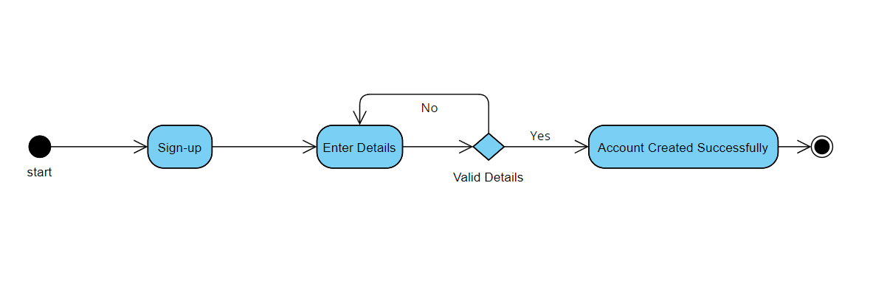

Figure 1- Requirement FR_01

1. 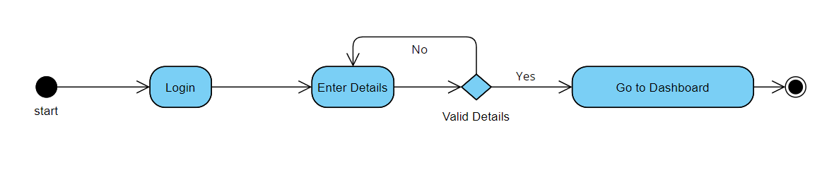**Login**

Figure 2- Requirement FR_02

1. 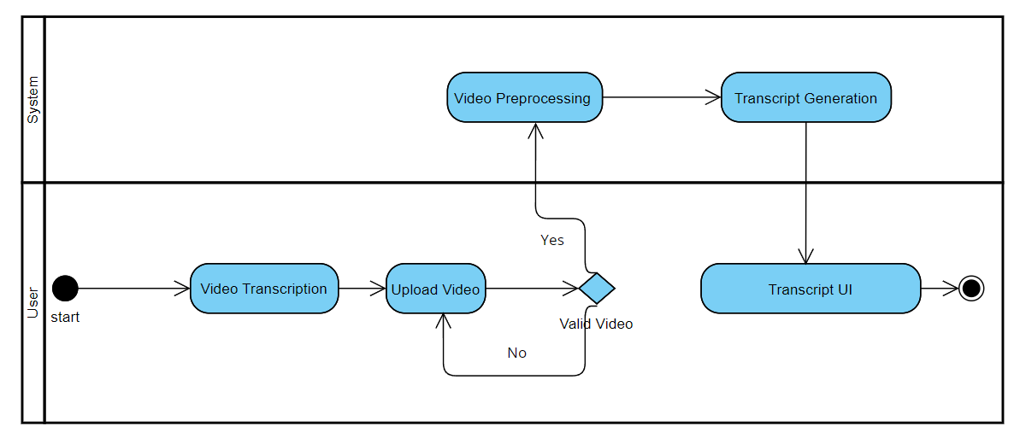**Video Transcription**

Figure 3- Requirement FR_03

1. 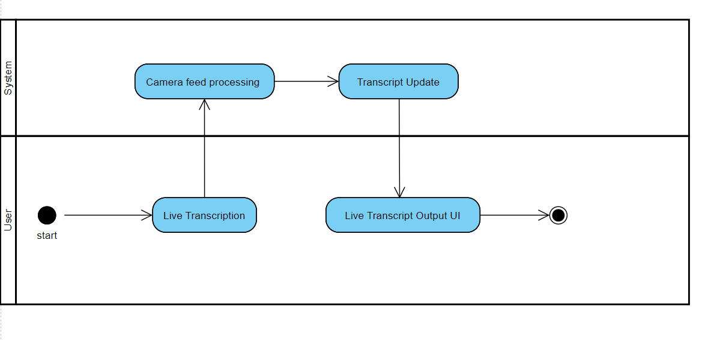**Real Time Transcription**

Figure 4- Requirement FR_04

1. **Track History**

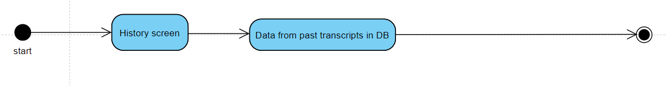

Figure 5- Requirement FR_05

* 1. **Sequence Diagram**

1. **Sign-up**

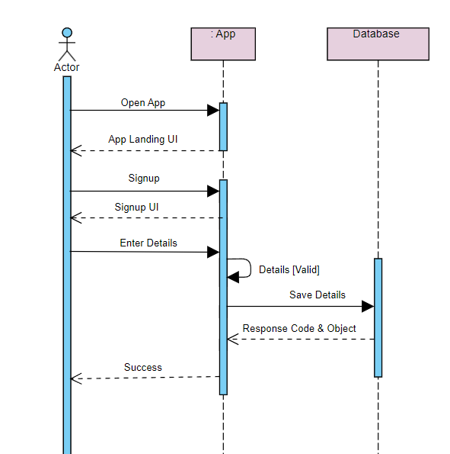

Figure 6 - Requirement FR_01

1. 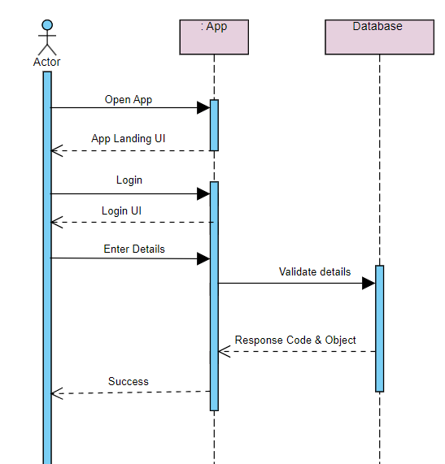**Login**

Figure 7- Requirement FR_02

1. **Video Transcription**

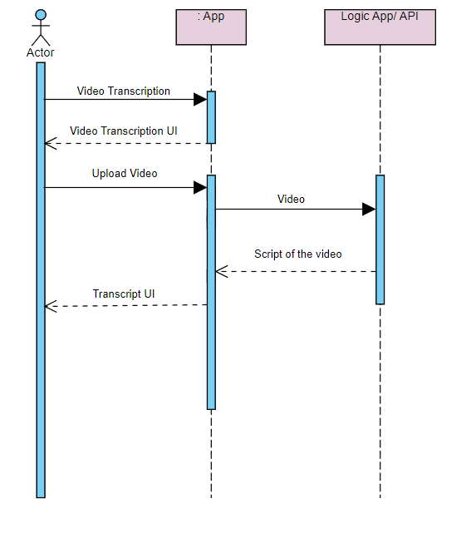

Figure 8 - Requirement FR_O3

1. **Real-Time Transcription**

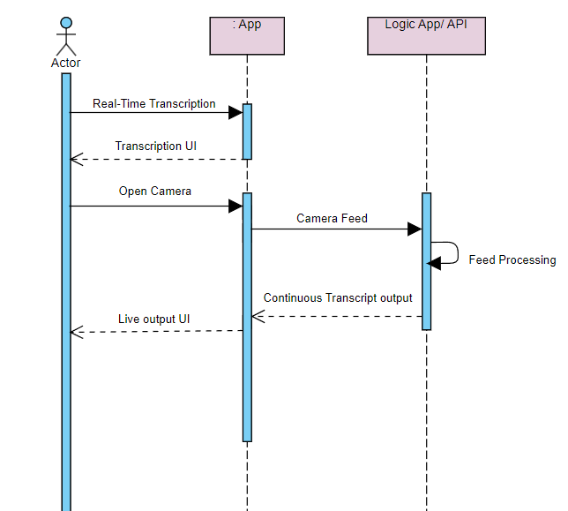

Figure 9 - Requirement FR_O4

1. **Track History**

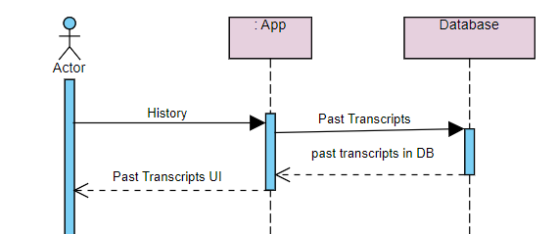

Figure 10 - Requirement FR_O5

* 1. **Collaboration Diagram**
  2. **State Transition Diagram**
  3. **Component Diagram**

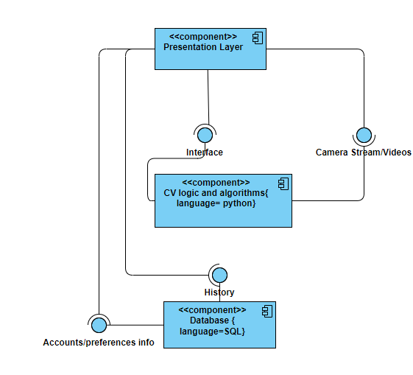

* 1. **Deployment Diagram**